



Bank Customer Churn Prediction
Submitted in partial fulfillment of completion of the course
AI MicroDegree
Year 2026

Submitted by:
Bhoomi:- Machine Learning, Web Application & Visualization , Video Making
Kashish Gautam:- Dataset handling, Documentation
Ashi:- Presentation
Khushi Khasyap:- Documentation

Under Guidance of:
Deepika singh (Edunet)
Abstract
Customer churn is a significant challenge in the banking sector, as losing customers can lead to financial losses and reduced business growth. Predicting customer churn helps banks identify customers who are likely to leave and take necessary actions to retain them. This project focuses on developing a Machine Learning based system to predict bank customer churn using historical customer data.

Data preprocessing techniques such as removing unnecessary columns, encoding categorical variables, and feature scaling are applied to prepare the dataset for model training. The trained model is saved using Pickle and integrated into a Streamlit web application to provide a simple user interface for prediction.

Acknowledgement
We would like to express our sincere gratitude to everyone who helped us in completing this project successfully. First of all, we would like to thank our teachers and mentors for their continuous guidance, encouragement, and valuable suggestions throughout the project development process.
We are also thankful to our college and department for providing the necessary resources and a supportive learning environment that helped us complete this project effectively.
Team Composition and Workload Division
Bhoomi:- Machine Learning, Web Application & Visualization , Video Making
Kashish Gautam:- Dataset handling, Documentation
Ashi:- Presentation
Khushi Khasyap:- Documentation

Table of Contents

Abstract.................................................................................... i
Acknowledgement .................................................................... ii
- Introduction to the Problem ............................................. 1
- Literature Review ................................................................. 2
- Proposed Solution ............................................................... 3
- Project Requirements ........................................................ 4
4.1 Technology Stack ......................................................... 4
4.2 Hardware Requirements ............................................. 5
4.3 Software Requirements .............................................. 6
4.4 Deployment Environment ......................................... 7
- User Requirements ............................................................... 8
- Design Documentation ......................................................... 9
- Implementation Details ........................................................ 10
- Testing and Validation ......................................................... 11
- Deployment ......................................................................... 12
- Future Scope ..................................................................... 13
- Conclusion ........................................................................... 1
Appendix A – Project Code ...................................................... 15
Appendix B – Project Screenshots .......................................... 16
Appendix C – Abbreviations ..................................................... 17
References ................................................................................. 18

- Introduction to Problem
Customer churn is a major problem in the banking industry. Banks invest a significant amount of resources in acquiring new customers. However, many customers leave the bank due to various reasons such as dissatisfaction with services, better offers from competitors, poor customer experience, or lack of engagement.
When customers leave the bank, it leads to financial losses and increased marketing costs for acquiring new customers. Therefore, it becomes important for banks to identify customers who are at risk of leaving and take preventive actions to retain them.

- Literature Review
Customer churn prediction has been widely studied in many industries such as banking, telecommunications, insurance, and e-commerce. Many researchers have developed different techniques to predict customer churn using data mining and machine learning methods.
Previous studies have shown that machine learning algorithms such as Logistic Regression, Decision Trees, Random Forest, and Support Vector Machines are effective in predicting customer churn. These models analyze customer data and identify patterns that indicate whether a customer is likely to leave.

- Proposed Solution
The proposed solution of this project is to develop a machine learning-based system that predicts whether a bank customer will churn or not.
The system works by analyzing a dataset that contains information about bank customers. The dataset includes features such as customer demographics, financial information, and account activity.

- Requirements
  - Technology Stack
• Python Programming Language
• Pandas for data analysis
• NumPy for numerical computations
• Matplotlib for data visualization

  - Hardware
• Processor: Intel i3 or higher
• RAM: Minimum 4GB
• Storage: At least 20GB free disk space

  - Software
• Python Programming Language
• Jupyter Notebook or Google Colab
• Operating System: Windows / Linux / MacOS

  - Deployment Environment
- The project can be deployed in a local development environment using Python and Jupyter Notebook.
- The required libraries can be installed using Python package managers such as pip or conda. Once installed, the system can process datasets and generate predictions.

- User Requirements
The user of this system should have basic knowledge of computers and data handling.
The user will provide the dataset containing customer information. The system will process the dataset, perform analysis, and apply the machine learning model to predict customer churn.

- Design Documentation
The system design describes the structure and workflow of the project.
The system begins with data input, where the customer dataset is loaded into the program. The next step is data preprocessing, where unnecessary columns are removed and missing values are handled.
After preprocessing, Exploratory Data Analysis (EDA) is performed to visualize the data and identify patterns. Finally, a machine learning model is trained using the processed data.

- Implementation Details
The implementation of this project was carried out using the Python programming language.
First, the dataset was loaded using the Pandas library. Data preprocessing techniques were applied to clean and prepare the dataset for analysis.
Next, various graphs and charts were created using Matplotlib and Seaborn to analyze relationships between different features.
- Testing
Testing is an important step to ensure that the system functions correctly.
The system was tested using sample datasets to verify whether the model produces accurate predictions. The performance of the model was evaluated using evaluation metrics such as accuracy and confusion matrix.

- Deployment
The project was successfully deployed in the Jupyter Notebook environment. The trained model can analyze customer data and generate predictions regarding customer churn.
In future, the project can be deployed as a web-based application or integrated with a business intelligence dashboard to make it more useful for banking organizations.

- Future Scope
The project can be further improved in several ways. Advanced machine learning algorithms and deep learning techniques can be applied to improve prediction accuracy.
The system can also be integrated with real-time banking databases so that churn predictions can be generated automatically for new customers.

- Conclusion
Customer churn prediction plays an important role in helping banks retain their customers and improve their services.
This project demonstrates how machine learning techniques can be used to analyze customer data and predict whether a customer is likely to leave the bank. By identifying high-risk customers in advance, banks can take preventive measures and develop better customer retention strategies.

Appendix A Project Code
{(A)Train_model.py}
# train_model.py

import pandas as pd
import pickle

from sklearn.model_selection import train_test_split
from sklearn.preprocessing import LabelEncoder, StandardScaler
from sklearn.linear_model import LogisticRegression

# Load dataset
df = pd.read_csv("Churn_Modelling.csv")

# Drop unnecessary columns
df.drop(["RowNumber","CustomerId","Surname"], axis=1, inplace=True)

# Encode categorical columns
le_gender = LabelEncoder()
df["Gender"] = le_gender.fit_transform(df["Gender"])

df = pd.get_dummies(df, columns=["Geography"], drop_first=True)

# Separate features and target
X = df.drop("Exited", axis=1)
y = df["Exited"]

# Train test split
X_train, X_test, y_train, y_test = train_test_split(
X, y, test_size=0.2, random_state=42
)

# Feature scaling
scaler = StandardScaler()

X_train = scaler.fit_transform(X_train)
X_test = scaler.transform(X_test)

# Train model
model = LogisticRegression(max_iter=1000)
model.fit(X_train, y_train)

# Save model
pickle.dump(model, open("churn_model.pkl", "wb"))

# Save scaler
pickle.dump(scaler, open("scaler.pkl", "wb"))

print("Model and scaler saved successfully!")

{(B) App3.py}

import streamlit as st
import pandas as pd
import numpy as np
import pickle
import seaborn as sns
import matplotlib.pyplot as plt

# PAGE CONFIG

st.set_page_config(
page_title="Bank Customer Churn Prediction",
page_icon="🏦",
layout="wide"
)

# CUSTOM CSS

page_bg = """
<style>

@import url('https://fonts.googleapis.com/css2?family=Poppins:wght@400;600;700&display=swap');

html, body, [class*="css"]{
font-family:'Poppins', sans-serif;
color:white;
}

/* BACKGROUND */

.stApp{
background-image:url("https://fintechweekly.s3.amazonaws.com/article/721/Revolut_Moves_to_Enter_Argentina_s_Banking_Sector_with_Planned_Acquisition_of_Banco_Cetelem.png");
background-size:cover;
background-position:center;
background-attachment:fixed;
}

/* MAIN CONTAINER */

section.main > div{
background:rgba(0,0,0,0.35);
padding:30px;
border-radius:15px;
}

/* TITLE */

h1{
color:#00E5FF;
font-size:70px !important;
text-align:center;
font-weight:800;
}

/* TAB HEADINGS */

h2{
color:#4FC3F7;
font-size:48px !important;
font-weight:700;
}

/* SUB HEADINGS */

h3{
color:#81D4FA;
font-size:38px !important;
font-weight:700;
}

/* TEXT */

p,label{
color:white !important;
font-size:22px !important;
}

/* DATAFRAME CONTAINER */

[data-testid="stDataFrame"]{
background:white !important;
border-radius:10px;
padding:4px;
}

/* TABLE FONT SIZE */

[data-testid="stDataFrame"] *{
font-size:38px !important;
}

/* TABLE BORDER */

table{
border-collapse:collapse !important;
}

table, th, td{
border:0.5px solid #e0e0e0 !important;
}

/* INPUT BOXES */

.stNumberInput input{
background:rgba(255,255,255,0.12) !important;
color:white !important;
font-size:20px !important;
border-radius:8px;
}

/* SELECT BOX */

div[data-baseweb="select"] > div{
background:rgba(255,255,255,0.12) !important;
color:white !important;
font-size:20px !important;
}

/* SLIDER */

.stSlider span{
color:white !important;
font-size:18px;
}

/* BUTTON */

.stButton>button{
background:linear-gradient(90deg,#00c6ff,#0072ff);
color:white;
font-size:22px;
font-weight:bold;
height:60px;
width:240px;
border-radius:10px;
border:none;
}

.stButton>button:hover{
transform:scale(1.05);
}

</style>
"""

st.markdown(page_bg, unsafe_allow_html=True)

# LOAD DATASET

df = pd.read_csv("Churn_Modelling.csv")

# LOAD MODEL

model = pickle.load(open("churn_model.pkl","rb"))

# TITLE

st.title("🏦 Bank Customer Churn Prediction")

st.write("Predict whether a bank customer will leave the bank.")

st.divider()

# TABS

tab1, tab2, tab3 = st.tabs([
"📊 Dataset Overview",
"📈 Data Visualization",
"🤖 Prediction"
])

# TAB 1

with tab1:

st.subheader("Dataset Preview")

st.dataframe(df.head(), use_container_width=True)

st.subheader("Dataset Shape")

st.write(df.shape)

st.subheader("Statistical Summary")

st.dataframe(df.describe(), use_container_width=True)

# TAB 2

with tab2:

st.subheader("Customer Churn Distribution")

fig, ax = plt.subplots(figsize=(10,6))

fig.patch.set_alpha(0)
ax.set_facecolor("none")

sns.countplot(
x="Exited",
data=df,
color="#00E5FF",
edgecolor="black",
linewidth=1.5,
alpha=0.8,
ax=ax
)

ax.set_title("Customer Churn Count", color="white", fontsize=26)
ax.tick_params(colors="white")

ax.set_xlabel("Exited", color="white", fontsize=20)
ax.set_ylabel("Number of Customers", color="white", fontsize=20)

ax.grid(alpha=0.3)

st.pyplot(fig)

st.subheader("Age Distribution")

fig2, ax2 = plt.subplots(figsize=(10,6))

fig2.patch.set_alpha(0)
ax2.set_facecolor("none")

sns.histplot(df["Age"], kde=True, color="#00E5FF", ax=ax2)

ax2.set_title("Age Distribution of Customers", color="white", fontsize=26)
ax2.tick_params(colors="white")

ax2.set_xlabel("Age", color="white", fontsize=20)
ax2.set_ylabel("Frequency", color="white", fontsize=20)

ax2.grid(alpha=0.3)

st.pyplot(fig2)

st.subheader("Balance Distribution")

fig3, ax3 = plt.subplots(figsize=(10,6))

fig3.patch.set_alpha(0)
ax3.set_facecolor("none")

sns.histplot(df["Balance"], kde=True, color="#FFA726", ax=ax3)

ax3.set_title("Balance Distribution", color="white", fontsize=26)
ax3.tick_params(colors="white")

ax3.set_xlabel("Balance", color="white", fontsize=20)
ax3.set_ylabel("Frequency", color="white", fontsize=20)

ax3.grid(alpha=0.3)

st.pyplot(fig3)

# TAB 3: PREDICTION
with tab3:
st.subheader("Enter Customer Details")

# Columns for input
col1, col2 = st.columns(2)

with col1:
credit_score = st.slider("Credit Score", 300, 900, 750) # example for "stay"
geography = st.selectbox("Geography", ("France", "Spain", "Germany"), index=0) # France = stay
gender = st.selectbox("Gender", ("Male", "Female"), index=0)
age = st.slider("Age", 18, 92, 40)
tenure = st.slider("Tenure", 0, 10, 7)

with col2:
balance = st.number_input("Balance", 0.0, 250000.0, 100000.0)
products = st.slider("Number of Products", 1, 4, 2)
credit_card = st.selectbox("Has Credit Card", (0, 1), index=1)
active_member = st.selectbox("Is Active Member", (0, 1), index=1)
salary = st.number_input("Estimated Salary", 0.0, 200000.0, 80000.0)

# Encoding
gender_encoded = 1 if gender == "Male" else 0
geo_germany = 1 if geography == "Germany" else 0
geo_spain = 1 if geography == "Spain" else 0
# France is baseline (drop_first=True in training)

# Feature array in exact same order as training
features = np.array([[
credit_score, # CreditScore
gender_encoded, # Gender
geo_germany, # Geography_Germany
geo_spain, # Geography_Spain
age, # Age
tenure, # Tenure
balance, # Balance
products, # NumOfProducts
credit_card, # HasCrCard
active_member, # IsActiveMember
salary # EstimatedSalary
]])

# Debug: check raw features
st.write("Features passed to model:", features)

# Load scaler and transform
scaler = pickle.load(open("scaler.pkl","rb"))
features_scaled = scaler.transform(features)

# Debug: check scaled features
st.write("Scaled features:", features_scaled)

# Predict
if st.button("Predict Churn"):
prediction = model.predict(features_scaled)

if prediction[0] == 1:
st.error("❌ Customer is likely to leave the bank")
else:
st.success("✅ Customer will stay with the bank")

{(Requirement.txt)}

Pandas
Scikit-learn
Streamlit
Joblib
Seaborn

Appendix B Screenshot of Project
{Dataset Overview}
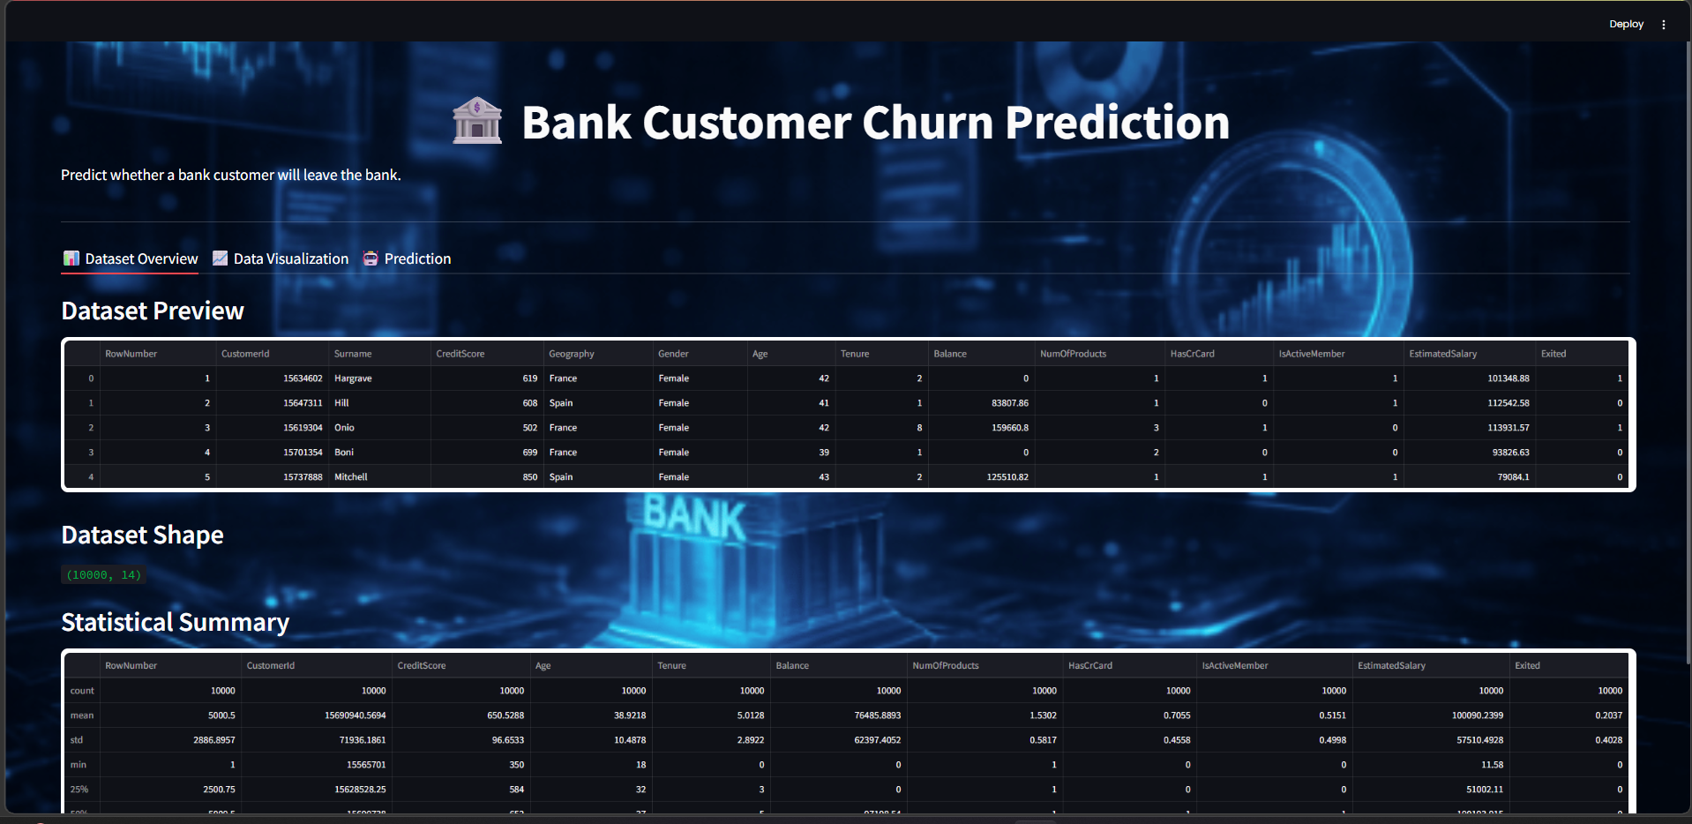
{Data Visualization}
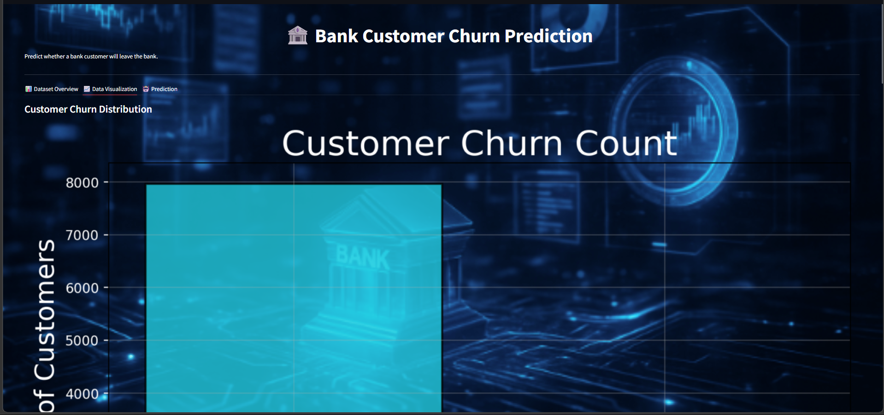
{Prediction}
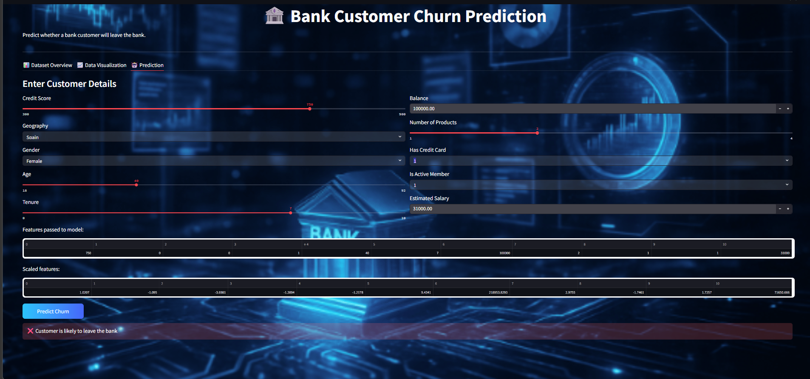

Appendix C abbreviation
AI – Artificial Intelligence
ML – Machine Learning
CSV – Comma Separated Values
UI – User Interface
API – Application Programming Interface
IDE – Integrated Development Environment
EDA – Exploratory Data Analysis
LR – Logistic Regression
RF – Random Forest
SVM – Support Vector Machine
KNN – K-Nearest Neighbors
DL – Deep Learning
GB – Gigabyte
RAM – Random Access Memory
CPU – Central Processing Unit
OS – Operating System
GUI – Graphical User Interface
DB – Database
PCA – Principal Component Analysis
JSON – JavaScript Object Notation
HTML – HyperText Markup Language
CSS – Cascading Style Sheets
References
• Python official documentation.
• Pandas documentation for data manipulation and analysis.
• NumPy documentation for numerical data processing.
• Scikit-learn documentation for machine learning model development.
• Streamlit documentation for building the web application interface.
• Seaborn documentation for data visualization and graphical analysis.
• Matplotlib documentation for plotting charts and graphs.
• Pickle / Joblib documentation for saving and loading trained machine learning models.
• Kaggle dataset documentation for Bank Customer Churn dataset.
• Machine Learning tutorials and resources for churn prediction model development.

